**DEBOUNCE Part 2**

Objective:

Design the same circuit as above but this time use a single push button to turn on and off the LEDs. For example, LED is switched off initially, when the push button is pressed red led turns on, when the same push button is pressed again yellow light turns on and red turns off and similarly when green turns on red and yellow turns off

TinkerCad Circuit Link:

<https://www.tinkercad.com/things/8yFcAQn8h8X-b-debounce/editel?sharecode=oOAugsZKmjVCJLpMjHce-T78wk2PwS2WudjWd74YlX4>

Circuit Diagram:

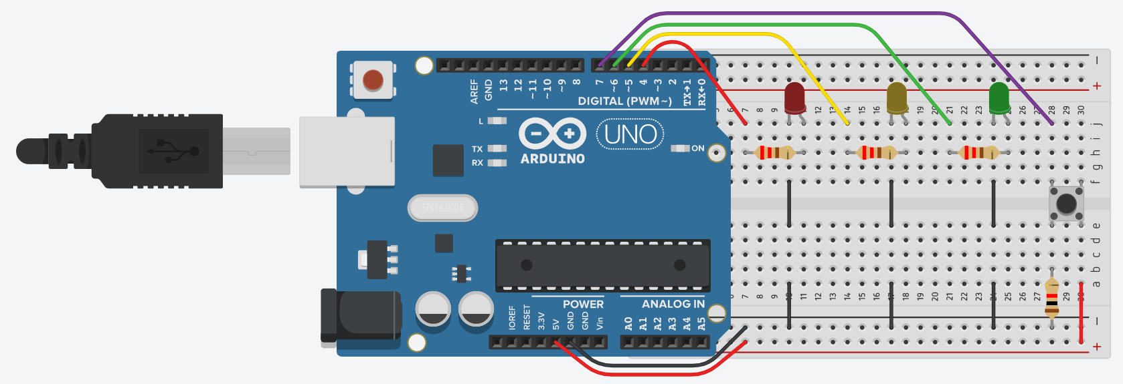

Code:

